ASSIGNMENT BOOKLET 4B

- The Quest for Canadian Identity
- Visions of National Identity
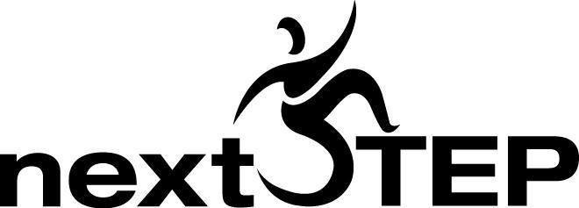
SENIOR HIGH SCHOOL
Fort Saskatchewan 780 992 0101
Sherwood Park 780 464 1899
Vegreville 780 632 7998

Social Studies 20-1 Chapter 15: The Quest for Canadian Unity

1. (Page 343) Chapter Issue

a) What is the Chapter Issue for Chapter 15?

b) What is the dilemma that the Canadian government often faces?

2. (Page 342) Chapter 15

a) Look at the collage of images on the chapter’s title page, “The Quest for Canadian Unity.” If you could delete one or two images, and replace them with your own choice of images, what would you delete, and what would you add?

b) What do you think are some ways to unite Canada, while at the same time promoting diversity?

c) What do you think are some possible things that challenge national unity in Canada?

d) What do you think are some changes that Canada has gone through over time that affect national unity?

3. (Page 344) What is National Unity?

a) According to the textbook:

“Those who feel a common bond with others or who have a strong sense of
belong to a particular group or collective often feel as if they are part of a
unified whole.”

To what extent do you agree with the above statement?

c) (not in textbook) Test the Textbook’s Claim

Test the textbook’s claim to see if there is a possible correlation (that is, a direct similar relationship) between the two concepts:

A. People who have a common bond with others or who have a strong
sense of belonging to a particular group

B. also often have a feeling that they are part of a unified whole

Answer the questions in the chart yourself, and ask two other people the following two questions.

#1 On a scale of 1 to 10 (10 being the highest) how strongly do you
feel connections to smaller groups in your life like your family, friends,
school, clubs or sports teams?

#2 On a scale of 1 to 10 (10 being the highest) how strongly do
you feel a connection to large groups in your life like your city, province
or country?

Name of person | Score for question A | Score for question B | Were scores similar/close or far apart?

According to your results, a similar score per person might suggest that the original statement is true to a certain extent. What kind of conclusion do your questionnaire results suggest?

d) (Page 344 continued)

When people feel a sense of

they identify with others who

e) Re-read the statement by former Canadian Prime Minister Pierre Trudeau.
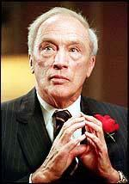

There is no such thing as a model or ideal Canadian.

What could be more absurd than the concept of an ‘all Canadian’ boy or girl?

A society which emphasizes uniformity is one which creates intolerance and hate.

Image accessioned on October 31, 2009 from http://www.wisdomportal.com/
Dates/PierreTrudeau.jpg

Place an X on the line below to show to what extent do you agree with Pierre Trudeau’s statement:

_____________________________________________________________________
To a great extent to a limited extent

Write out two questions that you would ask Pierre Trudeau to further clarify what he is trying to say.

4. (Page 344) Forces Affecting National Unity

What are some examples of internal and external events that affect a country’s citizens’ sense of national unity?

5. (Page 345) Canadian National Unity

In point form, write out five significant facts from this section that help you understand some of the challenges in maintaining Canadian national unity.

1.
2.
3.
4.
5.

6. (Page 346) Western Alienation

a) What do you think are some regional needs that the provinces on the east coast of Canada—like Newfoundland and Labrador, Nova Scotia and New Brunswick—would have that would be completely different from the needs of prairie provinces, like Manitoba, Saskatchewan, and Alberta?

b) Read the following excerpt, and answer the questions that follow.
The National Energy Program (NEP) was introduced on October 28, 1980 by the Liberal Party that was in power that year. The goal of the NEP was to increase overall Canadian control over the energy industry, especially control over oil and gas companies.
Many Albertans were upset over the NEP for several reasons. First of all, they saw the NEP as breaking the Canadian federal government breaking rules—the control of natural resources belongs to provinces. Second, some Albertans felt that the NEP was passed to benefit central Canada, particularly Ottawa. Many argued that Alberta lost a huge amount of money—estimates ran as high as $100 billion dollars. Third, Albertans were angered by the NEP due to the fact that a significant number of oil companies left the province of Alberta, leaving many Albertans unemployed.
To this day, the National Energy Program is a sore spot with many Albertans. The NEP is often cited as an example of federal government discrimination, which increased feelings of western alienation and led to the creation of many western separatist groups.
(Excerpt accessioned and paraphrased on October 31, 2009, from http://www.abheritage.ca/abpolitics/events/issues_nep.html)

Why was Alberta so defensive over the money possibly lost—shouldn’t Alberta be happy to share its wealth with other provinces?

Where did some Albertans think the benefits really went?

Why were Albertans angry?

c) Partly due to the National Energy Program, what was Kesler’s goal?

d) What was the central goal of the Alberta-led Reform Party?

7. (Page 348) Alienation in Other Regions

In two or three sentences, summarize why Danny Williams felt alienation in his province.

8. (Page 349) The Federal System and National Unity

a) Read this section, and explain why the British North America Act placed most of its key decision making power in the hands of the national government, and not the provincial governments.

b) Explain what it means that the Constitution was patriated?

9. (Page 349) Equalization Payments and Figure 15-6

a) What do equalization payments do for Canadians?

b) Below is a chart that summarizes the equalization payments in Canada
for 2009 to 2010. Compare and contrast the data in the chart below, and the data to the chart in the textbook in Figure 15-6. What are some significant similarities and differences, and what are your theories as to the differences?

Province | Payment Received  ($ Millions)
Prince Edward Island | $340
Nova Scotia | $14, 365
New Brunswick | $1, 689
Québec | $8,355
Ontario | $347
Manitoba | $2,063
Total | $27,159
Accessioned on October 31, 2009 from http://www.fin.gc.ca/fedprov/eqp-eng.asp

HOW HAVE THE PAYMENTS CHANGED LOOKING AT THIS DIAGRAM:

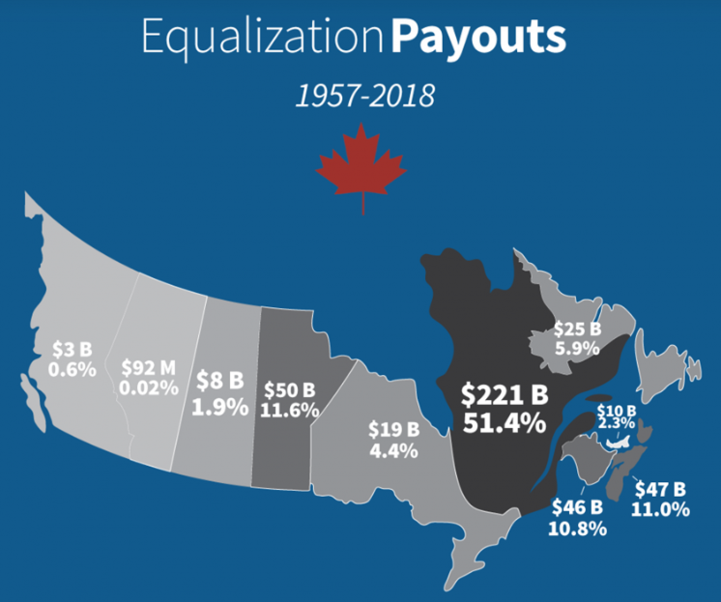
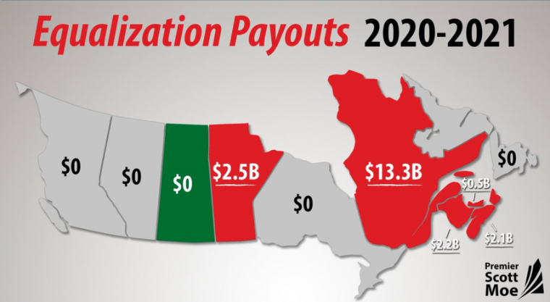

10. (Page 350) Political Representation and Figure 15-8
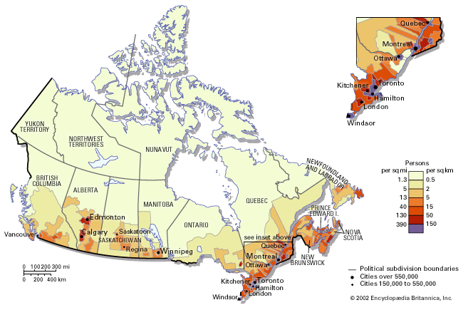
a) Below is a map that shows Canada’s population density. While the original map was in color, and this one is in shades of grey, you still can get the idea of where most Canadians live. You can access the original map, to view the details more accurately. (Map accessioned November 1, 2009 from http://media-2.web.britannica.com/eb-media/10/70010-004-BBFE93FB.gif)
What are 10 of the highest density cities that you can see, according to this map?

b) Explain why political representation is challenging in Canada.

11. (Page 350) Official Multiculturalism
a) When did Canada adopt multiculturalism and what motivated this new policy?

b) How is pluralism in Canada related to multiculturalism?

c) Why is it both a challenge and an opportunity to national unity in that it is “estimated that one in every six Canadians [is] a member of a visible minority group”? Create examples to support your explanation.

12. (Page 351-352) Québec Sovereignty and National Unity

a) One of the greatest challenges to Canadian national unity has been

and one of the greatest challenges to Québec nationalism has been

b) What does “maîtres chez nous” mean, and how does it relate to the goals of the Quiet Revolution? (note: check page 79 to review the Quiet Revolution)

c) What is the central issue that challenges Francophones across Canada?

d) What is a royal commission?

What did the Royal Commission on Bilingualism and Biculturalism discover?

e) Why did the B and B Commission arouse suspicion in Quebec and other parts of Canada?

What are some actions that the Canadian government took in response to the Bilingualism and Biculturalism Royal Commission?

13. (Page 352) Official Bilingualism
a) What are the goals of the Official Languages Act?

b) (Page 351) Voices
Summarize what either Trudeau or Harper believes about national unity.

14. (Page 356) Aboriginal Self-Determination and National Unity

a) What is the relationship between the Aboriginal peoples’ quest for self-determination and the concept of inherent rights?

(note: though the words are not quite the same, you may find it useful to think of the word inherent as similar to the word “inherit” which means you get something passed down from a family member that existed before you did)

b) Add details to the following timeline of events.

1982 Constitution:

Paul Martin

More recently

However, the Nisga’a and the Inuit

But, according to Stephen Cornell

15. (Page 357) Aboriginal Land Claims and National Unity

a) While the pace of settling Aboriginal land claims has been slow, what is one significant factor that has complicated the process of settling claims?

b) (Page 357) FYI

What are the two broad categories of land claims?

c) (Page 357) The Nisga’a Agreement

Which of the two broad categories of land claims does the Nisga’a agreement fall into?

What are two things that were agreed to in the Nisga’a settlement?

d) (Page 357) Nunavut

What is significant about the way Nunavut’s government is run?

e) (Page 358) A Different Model

The Nunavik region is still part of Québec, so it is not quite the same kind of settlement as Nunavut. In point form, list five facts that relate to the Nunavik agreement.

1.
2.
3.
4.
5.

Social Studies 20-1 Chapter 16: Visions of National Identity

16. (Page 366) Figure 16-1

a) Spend a few moments looking at the artwork created by Jane Ash Poitras. In three to five sentences, explore your own personal response to her comment:

“We have to be colour blind. For example, I use a lot of colour in my art,
but I don’t see myself as a Native artist. I see myself as a person.
I want to know about other people’s heritage, culture, and beliefs, but it
doesn’t matter what colour they are.

b) If you were creating your own wall mural about your own national identity, what kinds of images would you include?

17. (Page 368) What are some possible visions of nation?

What does civic nation mean?

c) Explain what the textbook is saying about Japan as a civic nation and how Japan’s national identity is based on two or more of the understandings of nation: linguistic, ethnic, cultural, religious, geographic, spiritual, or political.

d) Read the last two paragraphs of page 368. When some nations do not have a nation-state of their own, how do they form a national identity? Give an example to support your explanation.

18. (Page 369) Pluralism and Diversity

a) Explain pluralism.

b) Would students in schools 200 years ago have studied pluralism in their classrooms? Explain why or why not.

19. (Page 369) Evolving Identities

a) What are some things that happen to people as they move from one country to another?

b) If someone is described as cosmopolitan, what kind of person are they?

19. (Page 371) What are some possible visions of Canada?

a) Read the quote by Thomas D’Arcy McGee in the second paragraph, and the quote by Wilfred Laurier in the fourth paragraph. Explain what the main ideas are that the speakers are saying, and what the similarities and differences are between the two quotes.

b) What has happened to Canada as the 20th century unfolded?

c) What role does the Canadian Constitution have in preserving Canada’s national identity?

20. (Page 374-375) Aboriginal Nations Today

a) Analyze the statement below, and evaluate what you think are the potential challenges, and the potential benefits of this vision of Canada.

According to the 1996 report of the Royal Commission on Aboriginal peoples, Aboriginal governments are “one of the three orders of government in Canada—federal, provincial/territorial, and Aboriginal.”

Exploring Nationalism, Page 374.

b) (Page 375) Aboriginal leaders have agreed that they want to remain as nations WITHIN Canada, but the progress in achieving a measure of self-determination remains slow. How might the Report Card in Figure 16-11 help everyone to understand the promises made and the promises yet to be fulfilled?

21. (Page 376) Implications of a Nation of Nations

a) What is asymmetrical federalism?

b) (not in textbook) The model of asymmetrical federalism gravitates to being closer to the model used in United States, where each state has more power to govern, according to their needs, and less central power from the United States federal government.

Considering that the needs of each province and territory are very unique to their own regions, analyze and evaluate the pros and cons of provinces being given more power to take care of their own affairs, such as immigration, language issues, treaty settlements, and healthcare.

c) (page 376 continued) We know that there already is a degree of asymmetrical federalism in Canada; why does it still remain a contentious issue?

22. (Page 377) The View From Here

a) Read the speech by Gilles Duceppe. Summarize what Duceppe is saying in his speech, and explain what you think would make Duceppe happy.

b) Read the following excerpt from the textbook, and respond to the questions that follow.
Brigitte Haentjens, an award-winning theatre director who was born in France but who has worked in both Ontario and Québec, summed up the feelings of many immigrants when she told the Montreal Gazette: “I can’t be Québécois.” Haentjens said that she felt more at home among the Francophone minority in Ontario than in mostly Francophone Québec.”
Exploring Nationalism, Page 376

What seems to be Haentjens’ emotional response to her experience of living in Québec?

What is the relationship between Duceppe’s speech on page 377, and Haentjen’s experience of living in Québec?

23. (Page 378-379) North American Integration

a) According to this vision of Canadian identity, Canadians have a great deal in common with Americans in United States, so some people have suggested that Canada and United States should merge into one large nation.

Read the section, and summarize it in point form with eight key points.

b) (Page 379) Taking Turns

Respond to the question that Rick, Harley and Jean are answering:

“Is North American integration a sound idea?”

In your response, use quotes from the statements that Rick, Harley, and Jean make, as points that you either agree with or disagree with.

24. (Page 384) What is your vision of national identity? and Defining Your Vision

a) Is Ernest Renan being sarcastic, or is he exposing a significant truth about human nature? Explain, giving reasons for your response.
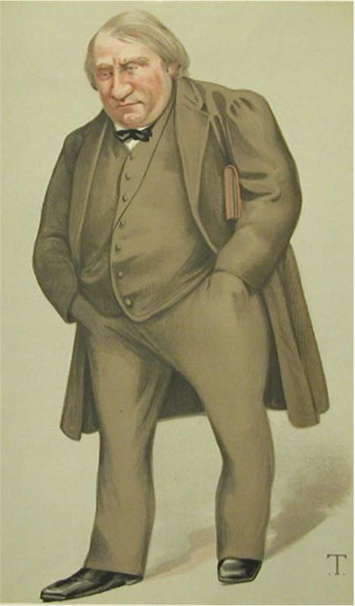
A nation is “a group of people united by a mistaken view about the past and a hatred of their neighbors.”

Image of Ernest Renan accessioned on November 4, 2009, from
http://www.masterandmargarita.eu/en/02themas/ontstaan.html

b) What does Edward Greenspon observe about Canadian patriotism?

Do you agree with Greenspon? Explain why or why not.

25. (Page 381) Canada and the World

WATCH: How the World Sees Canada

a) On a world stage, what is Canada often described as and why?

b) What were the complaints of Ban Ki-moon and Jeffrey Sachs about Canada?

c) Would you evaluate these complaints as valid? Give reasons and examples to support your response.


d) (page 381 continued)

What does Janice Gross Stein believe?

Is there truth in her words, or do you have a sense that she places too much responsibility upon Canada as a global leader? Explore your own personal beliefs on Janice Gross Stein’s statement.

e) Should Canada increase its leadership in solving world problems?

THE END! ALMOST!
SUBMIT THIS MODULE TO BRIGHT SPACE &
COMPLETE THE UNIT 4 QUIZ AND FINAL EXAM ESSAY!

